(Approx. 818 words)

OAG Joins the Facebook Generation(s)! Part 1
by Mike Morris, Editor, Front Range PC Users Group, CO
http://www.frpcug.org
twriterext (at) gmail.com

This article has been obtained from APCUG with the author’s permission for publication by APCUG member groups; all other uses require the permission of the author (see e-mail address above).

Hello everyone. I am writing to you as the Old Analog Guy again (a reminder: the acronym is OAG and is pronounced “ogre”).

You may find it surprising that this OAG has signed up for a Facebook account. I certainly surprised myself. However, I decided it was time to explore this . . . whatever it is when an older cousin sent me a message saying “check out my photos on Facebook.” With help from my 17 year old grand niece, I think I have figured out (at least some of) the basic mechanics of using this social network.

I don’t claim to understand the motivation behind the popularity of (electronic) social networks. The interests of advertisers in this phenomenon, are, however, very clear (more on that in a moment). The origins of this phenomenon (at least for Facebook) are in the east coast (US) universities around 2003 – 2004 (connect to http://en.wikipedia.org/wiki/Facebook for more history and discussion of this company). According to that Wikipedia article, “. . . within the first month [of launch], more than half [of] the undergraduate population at Harvard was registered on the service.” In 2005, Facebook launched a high school version, and in 2006 it was offered to the general public (everyone over the age of 13).

OK, I understand the interest in having friends and sharing conversation with friends. Even this OAG has a few friends (I think). What I don’t understand is this willingness (compulsion?) to share (almost) every last detail of your life in a public (or “semi-public”) way. That seems analogous to running around in a football stadium without any clothes and with 100,000 (or 60,000,000—the number of US Facebook users estimated in May of 2009*) screaming fans watching. And, of course, in today’s world, it has risks.

The current version of Facebook allows you to control what information to enter (and display). So . . . I am now a Facebook registered user, and I think I may have learned a little about how to use it, and, perhaps . . . possibly . . . maybe . . . a glimmer of understanding of why it is used.

The first page you see when you connect to Facebook is this:
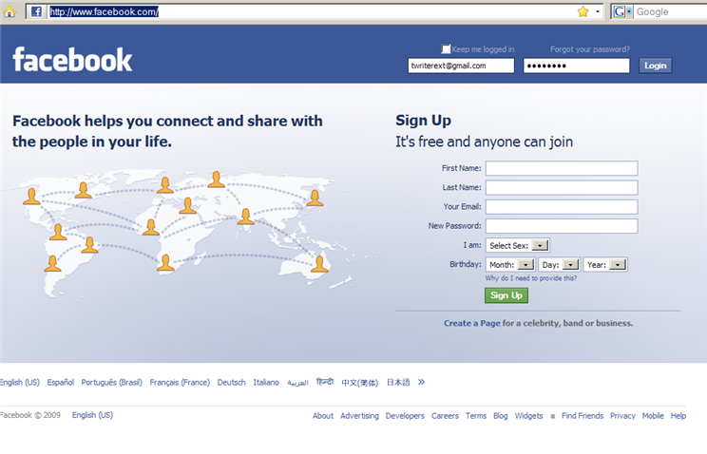

To register you need to enter the usual contact information, plus gender and birth date. Your birth date is the ONLY personal information (other than gender) that you are required to enter (and you can arrange so that it is not visible to anyone).

Once you register and log in, you are connected to your “home page.” Here is what my homepage looks like at the moment:

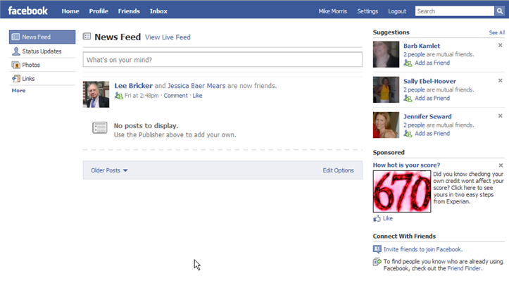

Probably the
first item that catches your eye is that large “670.” Yes, that is an advertisement, and advertising is the “fuel” that drives the social networking phenomena. So, if you find any or all of the ads objectionable (even for just being there), then you are, I am sorry to say, not a candidate for the “Facebook Generation” (I hope you are not too easily offended—after all every Google search results page has advertising). The ads (and “Suggestions”) change every few minutes, I think.

Before I go on with my description of the homepage—or any other page—I need to call your attention to the “Settings” button at the upper right of the page. If you use your mouse to move the pointer over that button, you will see a list of 4 choices:

Now click on the “Privacy Settings” choice, and you obtain access to a list of privacy controls:
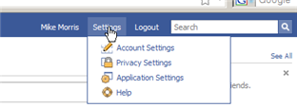 settings_01.png

There are several categories of these settings.
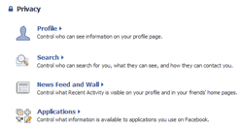

- Profile
- Search
- News Feed and Wall
- Applications

You can also block a name and/or an email address form this page.

Here is how I have set my Profile privacy settings:
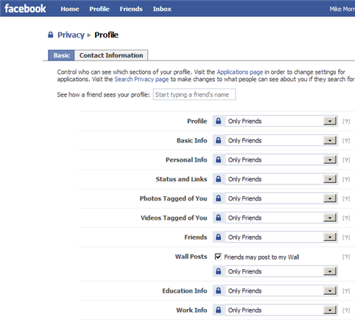

I have limited access to everything to “Only Friends” (another clue that I am still very much an OAG and have not made the transition to “Digital Man”).

The choices are:
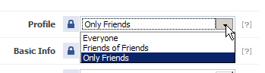

I have limited access to “Only Friends” for all information, including Contact Information and Search Visibility. If your reaction is “. . . but no one will be able to find you,” my response is that my “friends” will find me.

For more information on Facebook privacy settings, connect to http://arstechnica.com/web/news/2009/08/meshing-social-networking-and-privacy-on-facebook.ars.

Note that there are privacy settings for “News Feed and Wall.” Well folks, you need to learn the language.

News Feed is, as far as I can determine, the primary function of your homepage, and the Wall is another name for your Profile page. I will talk about those 2 pages in Part 2.

